**Assignment 28.2**

**Explain File Formats in Hive in Brief with an example.**

**File Format** :  
A **file format** is a way in which information is stored or encoded in a computer file. In Hive it refers to how records are stored inside the file. As we are dealing with structured data, each record has to be its own structure. How records are encoded in a file defines a file format.  
These file formats mainly vary between data encoding, compression rate, usage of space and disk I/O.  
Hive does not verify whether the data that you are loading matches the schema for the table or not. However, it verifies if the file format matches the table definition or not.

**TEXTFILE :**  
TEXTFILE format is a famous input/output format used in [Hadoop](https://acadgild.com/big-data/big-data-development). In Hive if we define a table as TEXTFILE it can load data of from CSV (Comma Separated Values), delimited by Tabs, Spaces, and JSON data. This means fields in each record should be separated by comma or space or tab or it may be JSON(JavaScript Object Notation) data.  
By default, if we use TEXTFILE format then each line is considered as a record.

**Creating textfile formatin hive then loading the data and then performing basic ‘select’ operation.**

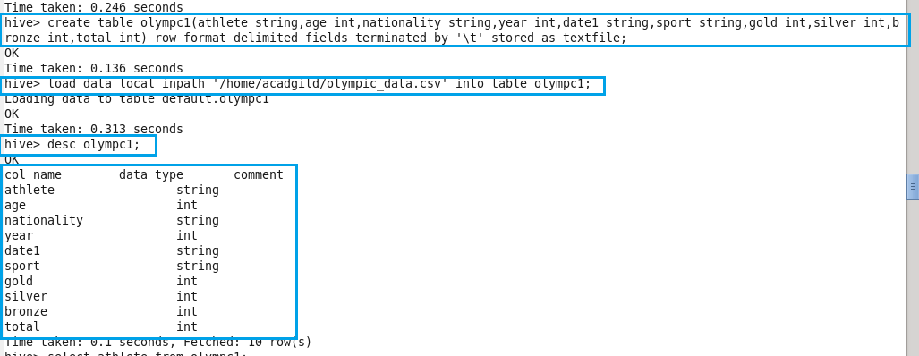

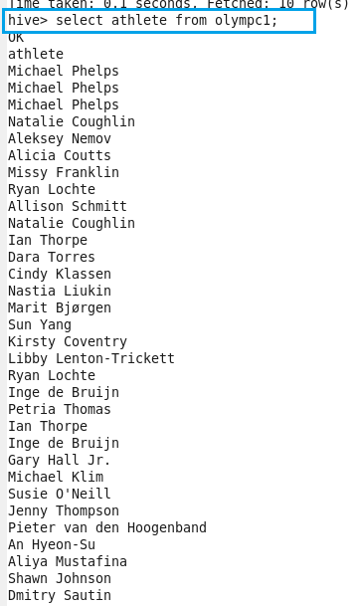

**SEQUENCEFILE**

Sequence files are flat files consisting of binary key-value pairs. When Hive converts queries to MapReduce jobs, it decides on the appropriate key-value pairs to be used for a given record. Sequence files are in the binary format which are able to split and the main use of these files is to club two or more smaller files and make them as a one sequence file.

In Hive we can create a sequence file by specifying STORED AS SEQUENCEFILE in the end of a CREATE table statement.

There are three types of sequence files:

• Uncompressed key/value records.

• Record compressed key/value records – only ‘values’ are compressed here.

• Block compressed key/value records – both keys and values are collected in ‘blocks’ separately and compressed. The size of the ‘block’ is configurable.

**Creating sequencefile format in hive then loading the data then inserting the data into created sequencefile from the existing table olympc1 and then performing basic ‘select’ operation.**

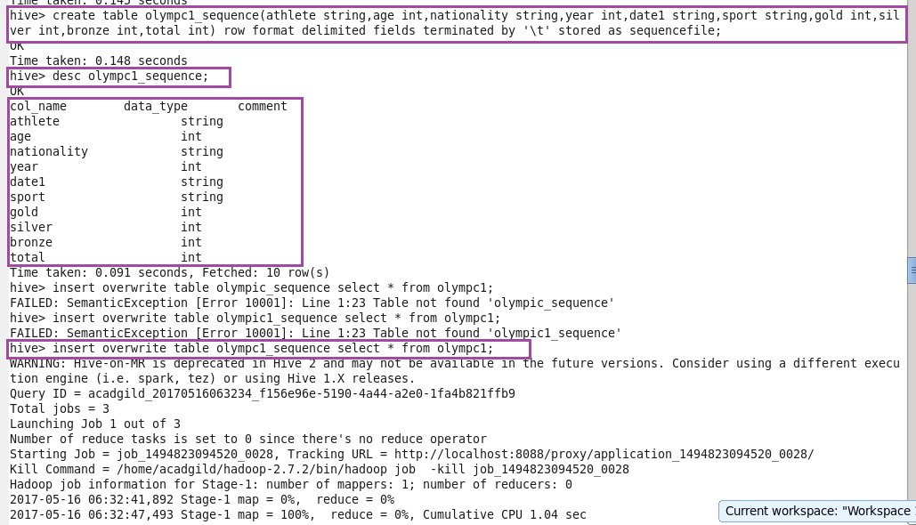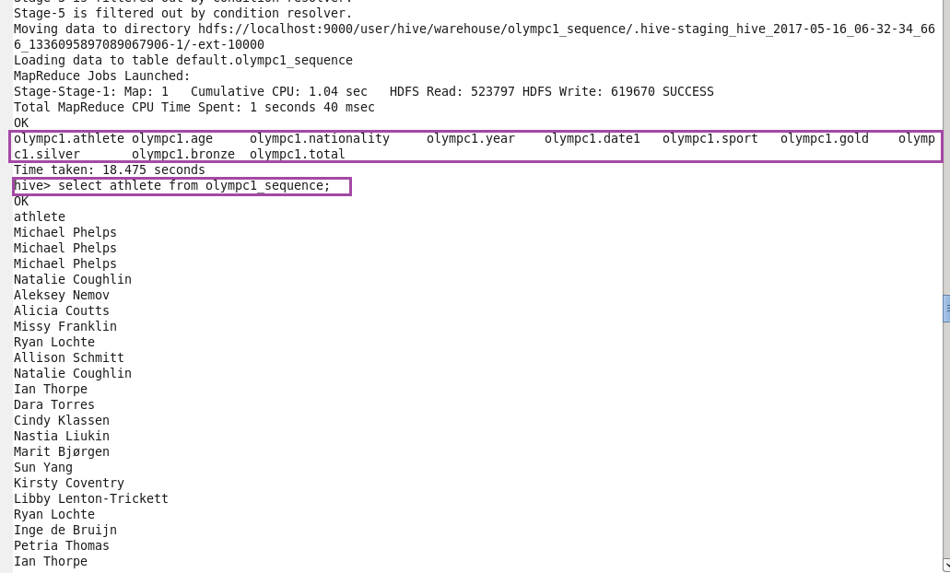

**RCFILE** :

RCFILE stands of Record Columnar File which is another type of binary file format which offers high compression rate on the top of the rows.  
RCFILE is used when we want to perform operations on multiple rows at a time.  
RCFILEs are flat files consisting of binary key/value pairs, which shares much similarity with SEQUENCEFILE. RCFILE stores columns of a table in form of record in a columnar manner. It first partitions rows horizontally into row splits and then it vertically partitions each row split in a columnar way. RCFILE first stores the metadata of a row split, as the key part of a record, and all the data of a row split as the value part. This means that RCFILE encourages column oriented storage rather than row oriented storage.  
This column oriented storage is very useful while performing analytics. It is easy to perform analytics when we “hive’ a column oriented storage type.  
Facebook uses RCFILE as its default file format for storing of data in their data warehouse as they perform different types of analytics using Hive.

**Creating rcfile format in hive then loading the data then inserting the data into created rcfile from the existing table olympc1 and then performing basic ‘select’ operation.**

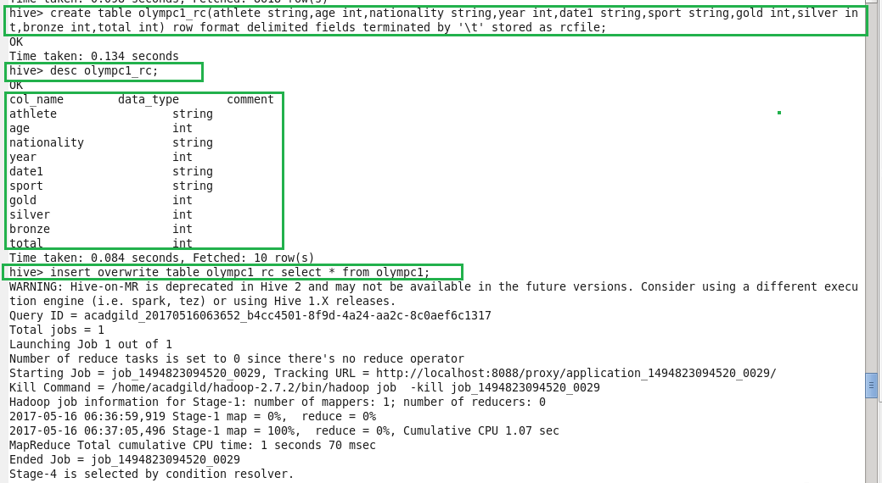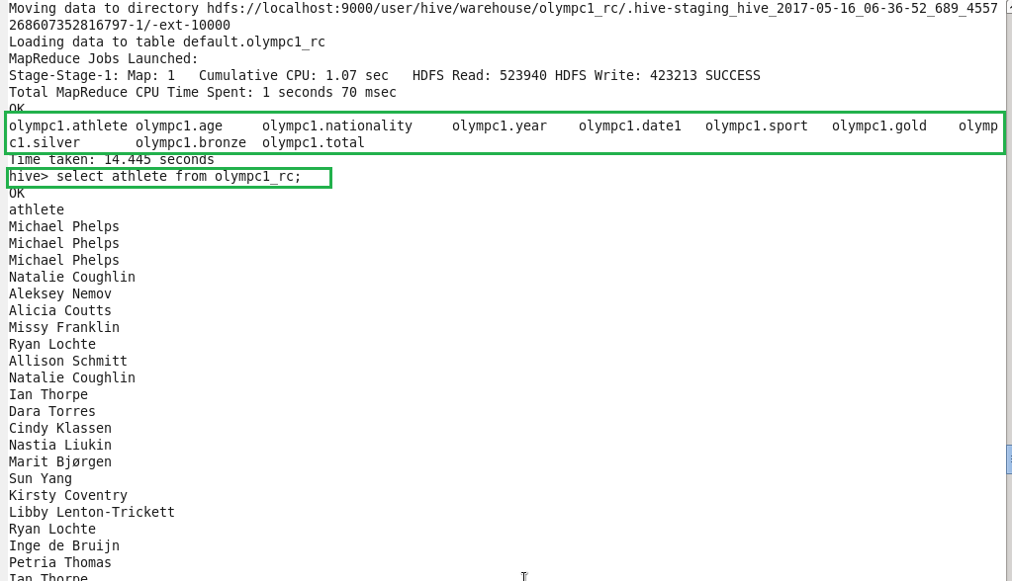

**ORCFILE :**

ORC stands for Optimized Row Columnar which means it can store data in an optimized way than the other file formats. ORC reduces the size of the original data up to 75%. As a result the speed of data processing also increases. ORC shows better performance than Text, Sequence and RC file formats.  
An ORC file contains rows data in groups called as Stripes along with a file footer. ORC format improves the performance when Hive is processing the data.

**Creating orcfile format in hive then loading the data then inserting the data into created orcfile from the existing table olympc1 and then performing basic ‘select’ operation.**

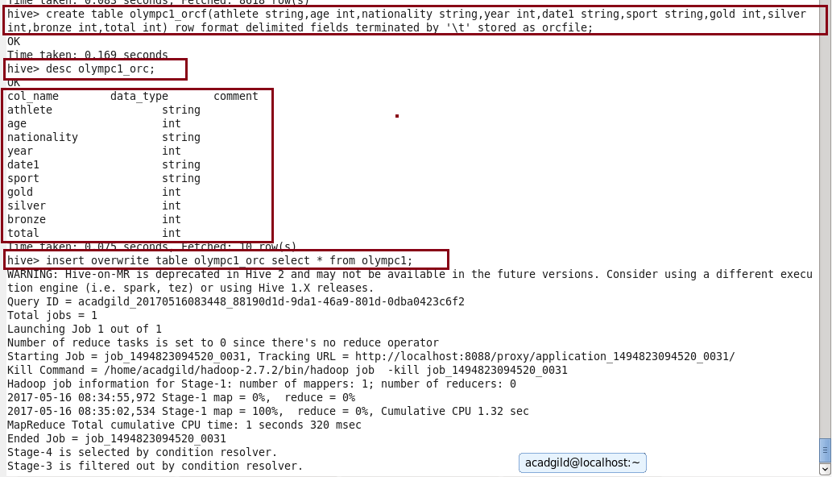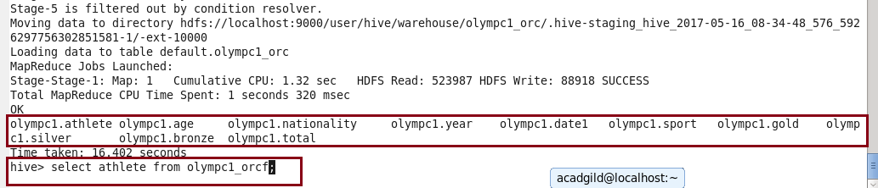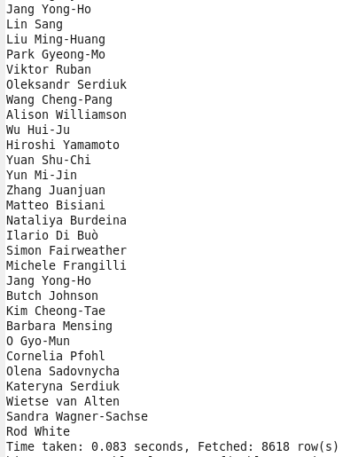

Thus you can use the above four file formats depending on your data.  
For example,  
a) If your data is delimited by some parameters then you can use TEXTFILE format.  
b) If your data is in small files whose size is less than the block size then you can use SEQUENCEFILE format.  
c) If you want to perform analytics on your data and you want to store your data efficiently for that then you can use RCFILE format.  
d) If you want to store your data in an optimized way which lessens your storage and increases your performance then you can use ORCFILE format.